AJAY KUMAR GARG ENGINEERING COLLEGE

DEPARTMENT OF CSE (DATA SCIENCE)

ROLL NO.- 2200271540113 NAME-SUHANI SAHU

SUBJECT - WEB DEVELOPMENT SEM-3rd BATCH-C

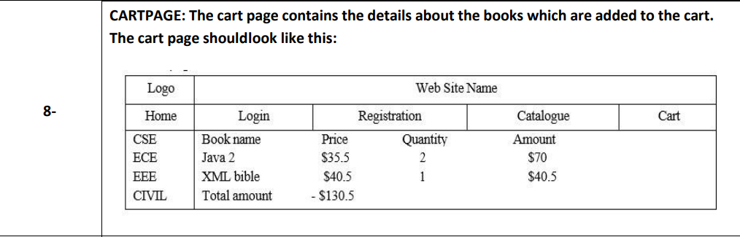

Code:

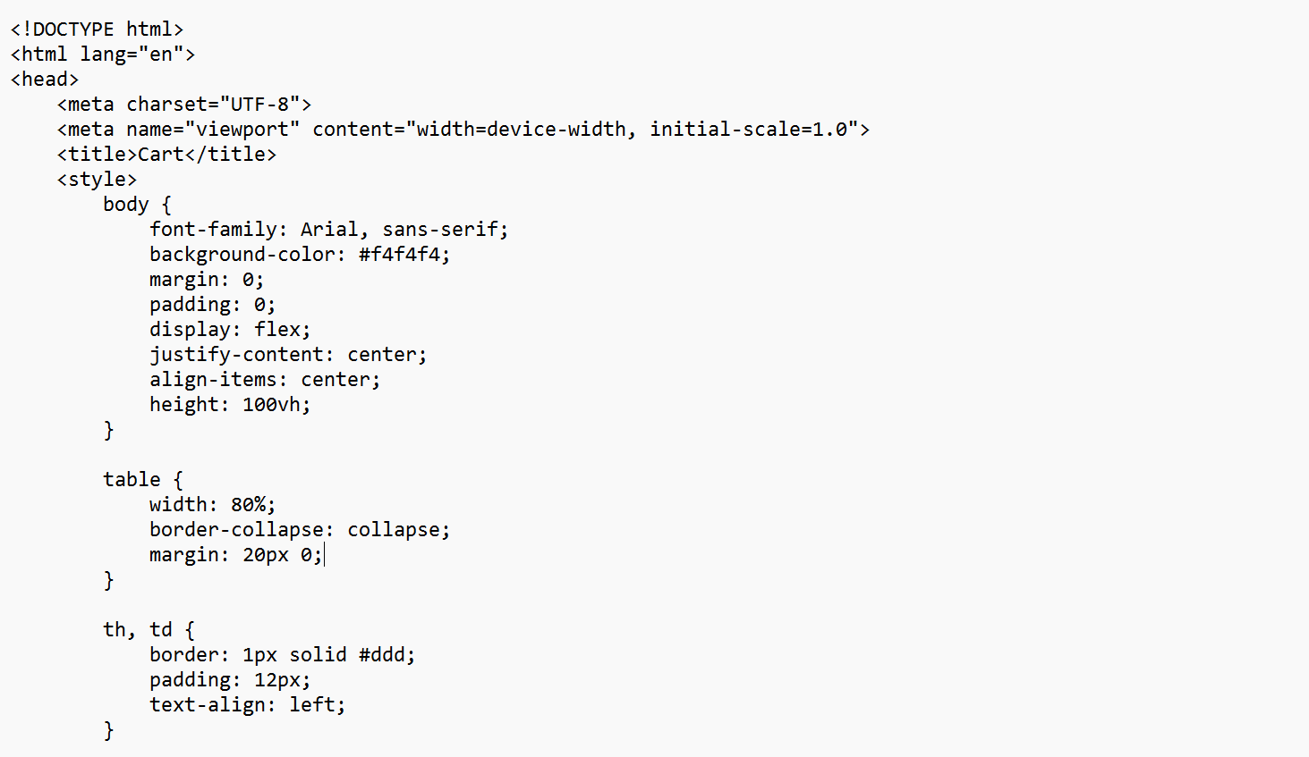

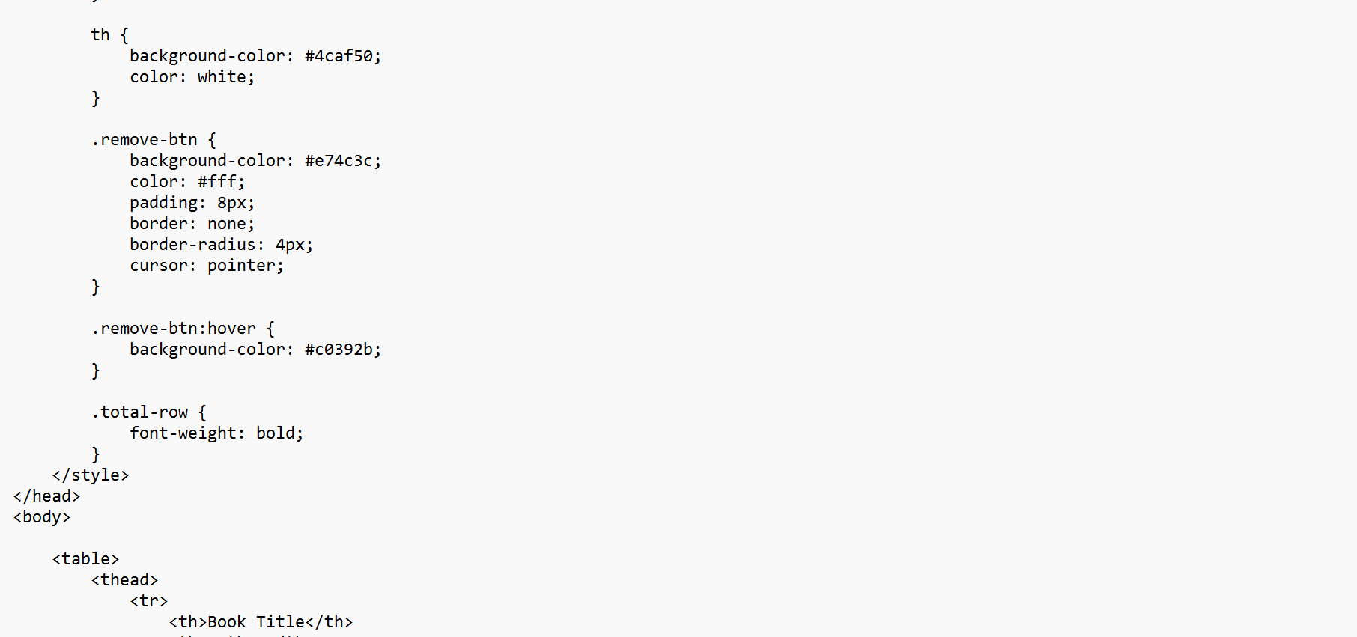

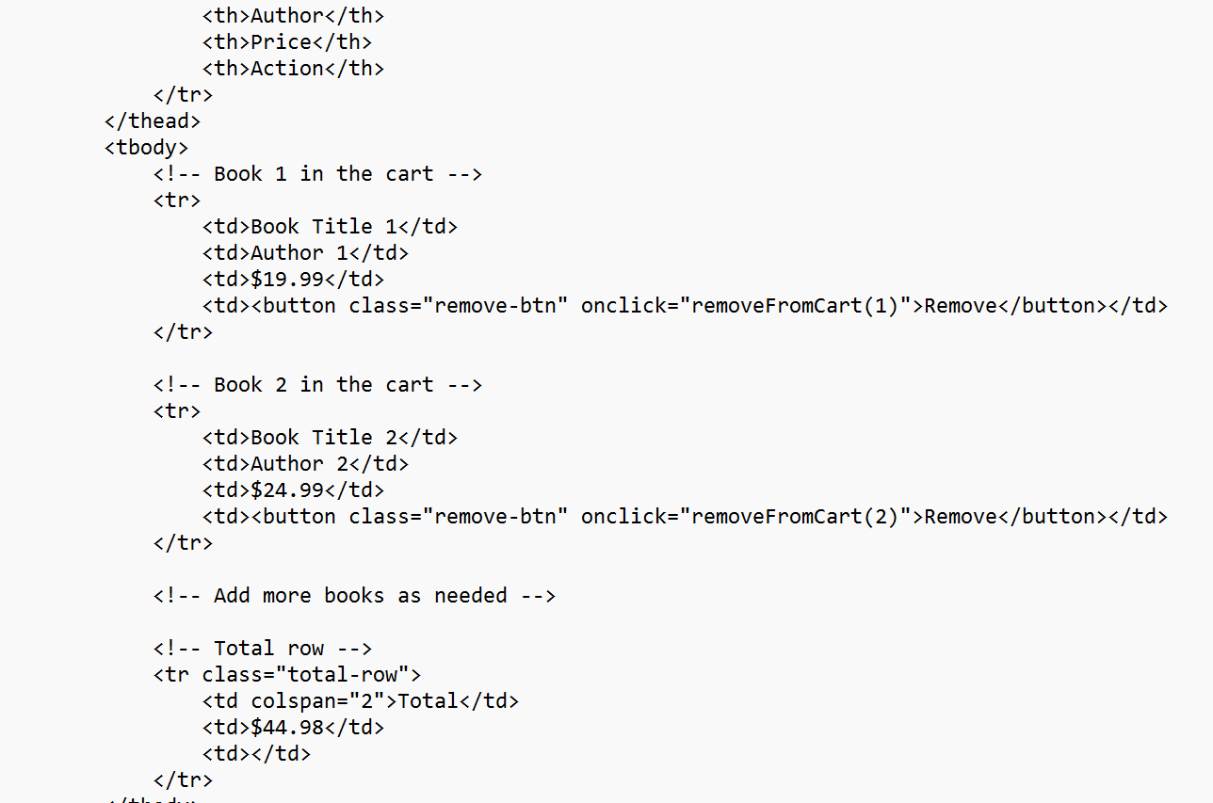

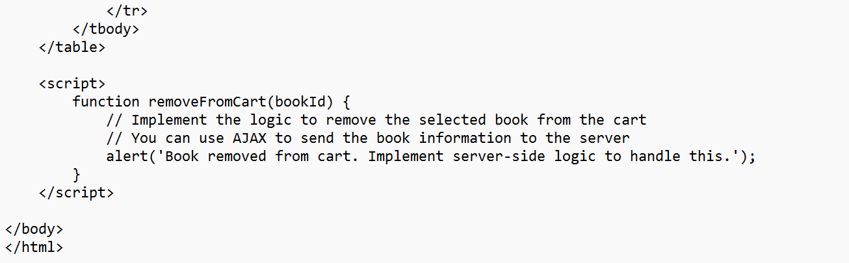

Output:

